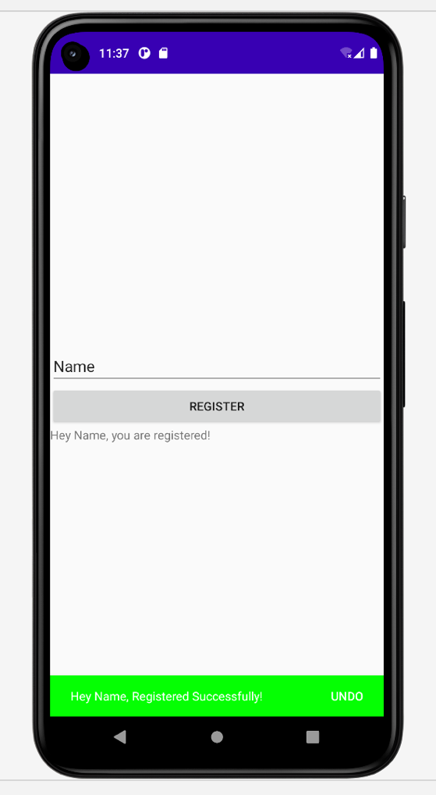

*<?***xml version="1.0" encoding="utf-8"***?>*<**LinearLayout xmlns:android="http://schemas.android.com/apk/res/android"  
 xmlns:app="http://schemas.android.com/apk/res-auto"  
 xmlns:tools="http://schemas.android.com/tools"  
 android:layout_width="match_parent"  
 android:layout_height="match_parent"  
 android:gravity="center"  
 android:orientation="vertical"  
 android:id="@+id/layout"  
 tools:context=".MainActivity"**>  
  
  
 <**EditText  
 android:id="@+id/editTextTextPersonName"  
 android:layout_width="match_parent"  
 android:layout_height="wrap_content"  
 android:ems="10"  
 android:inputType="textPersonName"  
 android:text="Name"** />  
  
 <**Button  
 android:id="@+id/button2"  
 android:layout_width="match_parent"  
 android:layout_height="wrap_content"  
 android:text="Register"** />  
  
 <**TextView  
 android:id="@+id/textView2"  
 android:layout_width="match_parent"  
 android:layout_height="wrap_content"  
 android:text="TextView"** />  
</**LinearLayout**>

**package** com.example.myapplication  
  
**import** android.content.Intent  
**import** android.graphics.Color  
**import** android.net.Uri  
**import** android.os.Bundle  
**import** android.provider.CallLog  
**import** android.provider.ContactsContract  
**import** android.provider.MediaStore  
**import** android.util.Log  
**import** android.view.View  
**import** android.widget.*  
**import** androidx.appcompat.app.AppCompatActivity  
**import** androidx.constraintlayout.widget.ConstraintLayout  
**import** com.google.android.material.snackbar.Snackbar  
  
**class** MainActivity : AppCompatActivity() {  
 **override fun** onCreate(savedInstanceState: Bundle?) {  
 **super**.onCreate(savedInstanceState)  
 setContentView(R.layout.*activity_main*)  
  
 **val** l:LinearLayout = findViewById(R.id.*layout*)  
 **val** ed:EditText = findViewById(R.id.editTextTextPersonName)  
 **val** b:Button = findViewById(R.id.button2)  
 **val** tv:TextView = findViewById(R.id.textView2)  
  
 b.setOnClickListener**{  
 val** name:String = ed.*text*.toString()  
 tv.setText(**"Hey $**name**, you are registered!"**)  
 **val** s:Snackbar = Snackbar.make(l,**"Hey $**name**, Registered Successfully!"**,Snackbar.*LENGTH_LONG*)  
 s.setTextColor(Color.*WHITE*)  
 s.setBackgroundTint(Color.*GREEN*)  
 s.setActionTextColor(Color.*WHITE*)  
 s.setAction(**"undo"**)**{** tv.setText(**"Hey $**name**, sad to see you de-registered!"**)  
 **val** sn:Snackbar = Snackbar.make(l,**"$**name **DeRegistered Successfully!"**,Snackbar.*LENGTH_LONG*)  
 sn.setBackgroundTint(Color.*RED*)  
 sn.show()  
 **}** Log.e(**"Checking"**,**"Information displayed"**)  
 s.show()  
  
 **}** }  
}